Welcome to Longscroft Children’s Nursery School.
Here at Longscroft we aim to provide a safe and secure environment for children to learn and develop in. We offer children the opportunity to develop their skills and gain a strong understanding of the world around them. This is done by providing stimulating activities for the children and encouraging them to take risks with the support of our practitioners. We believe in the importance of working with parents to ensure your child receives the best possible care and experiences.
Longscroft Children’s Nursery School is set in a spacious environment where children can play freely between the indoor and outdoor environment. We can offer children the freedom and the space to learn about the world first hand and observe the changes in the environment which surrounds them. Our nursery has been created into four different areas.
We have our Bumble Bees room which cares for children 3 months to 2 years. The little ones have their own garden to explore with their own resources to help them develop.
We then have our Dragonflies room which cares for children aged 2 years to 3 years old. This room offers the children their own free flow area where they have created their personal growing garden and space to play.
We have two pre-school rooms which care for 3- to 4-year-olds and 4- to 5-year-olds. These rooms are Ladybirds and Butterflies which both have free flow areas so the children can choose whether they would like to play inside or out.
We have a large, grassed area for all the children to explore; this area provides resources which offer children the opportunity to develop their physical skills and to learn about their environment. Our setting also offers a spacious playground where children can develop their skills on bikes and cars with ease. The children can make use of the outdoor chalk boards which can really encourage their creative skills on a large scale. We also offer our children the opportunity to work and play with us in our sensory garden. This is a place created for the children to relax and enjoy nature, they have planted herbs in the garden which they enjoy smelling. The sensory garden attracts wildlife so the children can play in an environment which is surrounded by nature. We have recently added an allotment for the children to grow vegetables and flowers. We hatch eggs in an incubator and care for the chickens for a few weeks before passing them to a farm. We have a new sensory room which the children enjoy throughout the week.

Bumble Bees
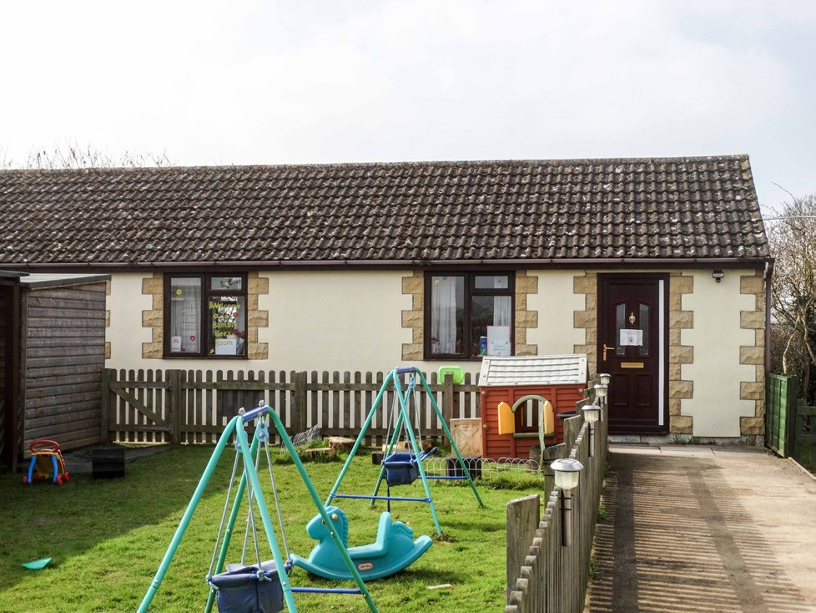
Bumble Bees cares for up to fifteen babies at any one time with a staff ratio of one adult to three children. All children have a ‘Learning Journey File’, which records your child’s journey as they develop. Bumble Bees has a wide selection of resources which encourage your child’s play. To ensure information is shared between practitioners and parents we provide a diary so details such as sleep, and feeds are recorded for you. However, it is our aim to ensure all parents have time to speak with our practitioners at the beginning and end of the day. The diary can also be used by you to inform the child’s key person of any changes, information or inform them of the child’s last feed.

Dragonflies
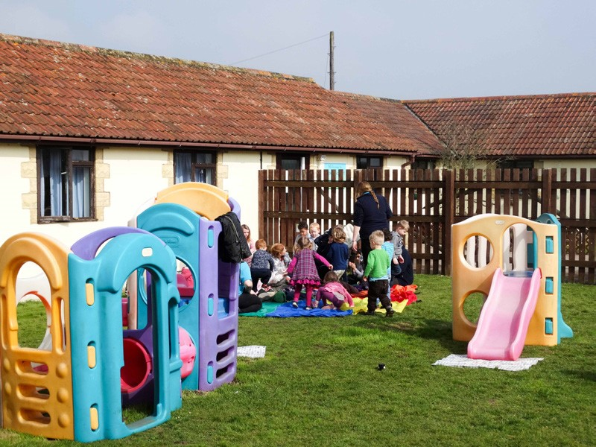
Dragonflies provide care for up to twenty-four children with a staff ratio of one adult to four children. The children have the freedom to choose whether they play inside or outside. Whichever area your child prefers to play in, we believe that whatever we do inside we can do outside. Therefore, children never miss out on opportunities as we often take our activities and resources outside with the children. The children are given the opportunity to have their morning and afternoon snack outside in the garden, weather permitting. The children are encouraged to develop their social skills in this room by providing opportunities for children to play together in a supportive and caring environment. Our practitioner’s role model good behaviour and encourage the children to behave in the same way. Activities
are provided for the children to support their development across all areas giving them the opportunity to explore and gain knowledge and understanding of the world around them first hand.

Ladybirds and Butterflies
Ladybirds and Butterflies have up to thirty-two children and twenty-six children respectively with a staff ratio of one adult to eight or less children. Ladybirds is for children aged 3-4 years and Butterflies is for 3-5 years and will prepare your child for the transition into school. The children are encouraged to gain an understanding of the world around them by exploring it for themselves. This is created by offering experiences such as observing the life cycle of chicks, butterflies, and frogs. Both rooms take turns in having chick eggs in an incubator which the children can care for and then watch hatch into tiny chicks. The children observe the changes over the next week and see first-hand how the cycle works. We also have butterfly nets so the children can experience the changes of a caterpillar into a chrysalis and then finally into a beautiful butterfly which we release into the wild.

We believe children learn better when they can experience these opportunities in their own environment. We encourage the children to ask questions and ensure we value the child’s voice. Stimulating activities are provided which reflect the child’s interests. We feel children learn better when they show an interest in an activity.

Important Information
Opening times
We are open between 7.30am and 6.00pm Monday to Thursday and 7:30am – 5pm on a Friday.
We are closed only on Bank holidays and for various days over the Christmas period, which we will give prior notice.
Session times:
Morning session | 8am –12.45
Afternoon session | 1.15pm – 6pm
Short day | 9am – 3pm
Full day | 8am – 6pm/5pm on a Friday
Early morning | 7.30am – 8am (£3.50 extra)
With funding (including 30 hours):
Morning session 9am –12.45
Afternoon session 1.15pm – 5pm
Short day 9am – 4:30pm
Full day 8am – 6pm
Early morning 7.30am – 8am (£3.50 extra)
Meals and snacks
Breakfast is available at a charge of £1.10; this consists of a bowl of cereal or toast and a drink of milk.
Mid-morning and mid-afternoon your child will be offered a choice of milk or water, a selection of fresh and dried fruit or chopped raw vegetables and a sweet or savoury biscuit. Lunch consists of a healthy two-course meal at an additional charge of £2.70 or your child can bring a packed lunch. Tea is available at a charge of £1.65. We offer a wide choice at teatime, for example, beans on toast and sandwiches with various fillings. Tea also includes yoghurt and a piece of fruit. Meals are offered but we are happy for children to bring their own food in to the setting. We are a NO NUT nursery.
We offer a sibling discount of 100% for meals.
Health and welfare
Please let us know of any health problems your child may suffer from and any medication taken. If your child has an infectious illness, it will not be possible for your child to attend Nursery as the illness may spread. A quiet area is provided for younger children who wish to sleep during the day.
Bringing and collecting your child
If you are unable to collect your child at the set time, please contact us in advance. At no time will your child be allowed to leave the Nursery in the care of another adult without previous consent from yourself. We use a PASSWORD system, please ensure your child’s Key Worker and manager are aware of this password.

Bad Weather/Closures
In the event of severe weather such as heavy snow, we will do everything possible to remain open, however, if we are unable to keep our site safe or maintain adequate staff ratios then we may have to make the decision to close the nursery. If this should happen we will not refund fees.

We are closed every bank holiday throughout the year and any funding allocated to these days will not be reimbursed.

Extraordinary Events
For extraordinary events such as infection spread (i.e. Coronavirus) we will always remain open where possible but if this is not possible due to H&S, legislative or other reasons we will not reimburse fees.
Fee information (Prices from 1st April 2020)
Normal sessions without funding:
Hourly AM/PM Short Day Day Week
Under 2 7.15 31.50 41.50 55.50 247.00
2-3 yrs 7.00 30.50 39.00 53.50 236.00
3 yrs + 6.85 29.50 38.00 51.50 224.00

Breakfast £1.10 Lunch £2.70 Tea £1.65 All £4.80
Sports – Pre-school £1.50 – This are for children who attend on a Tuesday afternoon at present. An outside agency comes in to support physical development. This will be included in the consumables from September 2022, for funded children only.
From September 2022
For children attending sessions funded by the Early Years Entitlement, an additional consumable charge of 75p per funded hour will be applicable. This hourly charge covers the cost of the following consumables wipes, drinks, snacks, all craft supplies and resources. All children can claim 570 funded hours per year, working families may also be eligible for the Extended Entitlement of funding a total maximum of 1,140 funded hours per year. Additional hours above funded sessions will be charged at our hourly rate as shown above. Please speak to the nursery manager for more information.
Please note that Longscroft Nursery is subject to an annual fee increase in the month of April. Fee literature is reviewed on an annual basis, any changes will be given as much notice as possible.
Fees need to be paid in advance monthly. Payment can be made by cash, cheque, childcare vouchers or directly into our bank account. Cheques should be made payable to Longscroft Children’s Nursery School. Unfortunately, we do not have a card machine facility.

A charge of 10% of the balance will be made for payments not made by the 15th of the month and refusal of admission until the invoice is clear. Reminders are sent out on the 16th of each month. All absences must unfortunately be paid for. Holiday entitlement is 3 weeks, during these periods you will be charged at half the weekly rate if notified at least a month in advance. Withdrawal of your child is one months’ notice, or one month’s fees in lieu of notice (date to date).
Late collection fee – A charge of £10.00 for every fifteen minutes will be made for any collection after 6pm.
Please note that all invoices not settled within our payment terms will be referred to our Debt Recovery Agents, Final Demand Ltd and will be subject to a surcharge of 15% plus VAT in lieu of our recovery charges.
Our complaints policy can be found on our website, outside the office or can be emailed directly to the office. office@longscroftnursery.co.uk
A registration deposit of £50.00 is required for all new bookings. £25.00 of this is refundable when your child leaves the nursery if one month’s notice is given. If your child is only accessing funded hours, there is no administration fee. A charge of £10 will be levied on bounced cheques to cover bank and administration charges.

Funding
At Longscroft we offer 3 and 4-year-old funding. Children can attend on our funded sessions and are not dependant on parents paying for additional non funded hours. Please see our session times in this prospectus. Funding can be allocated 15/30 hours per week for term time only or throughout the year (52 weeks). For more information, please contact the office. Term times (38 weeks) are displayed outside the office. Stretched funding is 22 hours per week and this cycle runs from September – August. If your child claims 15 hours per week and you would like to stretch this throughout the year you will receive 12.5 hours per week from September – March and 8.75 hours per week from April – August. We also accept 2-year-old funding; however, we will need to see the ‘approval of funding’ letter prior to enrolment from Wiltshire Council. 2-year-old funding must be applied for through Wiltshire Council
The date you start claiming depends on your child's birthday.
Child's birthday | When you can claim
1 January to 31 March | The beginning of term on or after 1 April
1 April - 31 August | The beginning of term on or after 1 September
1 September - 31 December | The beginning of term on or after 1 January
Your child is eligible for the universal entitlement up until the end of the term in which they turn five.
In Wiltshire, you can choose for your child to start school in the September after they turn four. When your child starts school, their entitlement stops, unless they attend a private, fee-paying school. They must be in full time education at the start of the term after they turn five.
You don't need to do anything, except inform your early years provider that you wish to access the early years entitlement through them.
Your provider is responsible for claiming the funding for your child from Wiltshire Council and will ask you to confirm your child's details and sign a termly headcount form. Children must be enrolled at the nursery prior to headcount week unless you qualify for late starter criteria.
You can split your child's entitlement between a maximum of two early years providers at any one time: three if your child has special educational needs and one early years provider is a district specialist centre. If your funding is being shared, ideally this should be on a term time basis.
30-hour funding
Where both parents are working (or the sole parent is working in a lone parent family), and each parent earns, on average:
- A weekly minimum equivalent to 16 hours at national minimum wage (NMW) or national living wage (NLW), and less than £100,000 per year
- The minimum income requirement for a parent (over the age of 25) is £120 a week. The minimum wage for ages 21 to 24 is £7.05 an hour, therefore, the minimum income requirement for this group is £112.80 a week.
A parent will expect (on average) to earn this amount over the coming three months. The eligibility criteria have been designed to accommodate parents with fluctuating incomes and those who are about to start working or increase their hours.
For example, a parent who is on a zero-hours contract will get work some weeks, but not others, and may not know in advance if they will have work in any given week. If, on average they work two weeks out of every three, and when they are working, they get 25 hours of work at the minimum wage, their child will qualify for 30 hours of free childcare.
Families where one parent does not work (or neither parent works) will not usually be eligible for the extended entitlement EXCEPT where:
- Both parents are employed but one or both parents is temporarily away from the workplace on parental, maternity or paternity, adoption leave, or on statutory sick pay
- One parent is employed and one parent either has substantial caring responsibilities based on specific benefits received for caring, or is disabled or incapacitated based on receipt of specific benefits
Parents can be employed or self-employed.
Parents are required to apply for the extended entitlement of 15 hours childcare through Childcare Choices website. Parents must renew their 30-hour code approximately every three months via HMRC/Childcare Choices account.

For advice and guidance on Government help with childcare costs for parents, please visit: GOV.UK Childcare Choices website

Eligibility for 2-year-old funding
Parents who are in receipt of one of the following:
- Income Support
- Income based Job Seekers Allowance (JSA)
- Income related Employment and Support Allowance (ESA)
- Universal Credit - if you and your partner are on a low income from work (this usually means a combined income of less than £15,400 a year after tax)
- Support under part six of the Immigration and Asylum Act 1999
- The guaranteed element of State Pension Credit
- Tax credit and have an annual household income of less than £16,190 (as assessed by HM Revenue and Customs).
Or if the 2-year-old:
- Has a statutory statement of Special Educational Needs (SEN) or an Education, Health and Care plan. As statements and statutory plans are issued by Wiltshire council, we are able to identify these children internally. Therefore, parents are unable to self-refer for funding based on this criteria
- Has left local authority care through a Special Guardianship Order, adoption or a Residence Order
- Is currently a Looked After Child, for example in foster care
- Is in receipt of Disability Living Allowance (DLA)

If you are a non-UK citizen who cannot claim benefits
If your immigration status says you have 'No Recourse To Public Funds' (NRPF), you might still get free childcare for your 2 year old. If you wish to apply, please go to the 'apply and check progress of applications' section and then download and complete the application.
You must live in England and your household income must be no more than:
- £26,500 for one child outside London
- £30,600 with two or more children outside London
- You cannot have more that £16,000 in savings or investments.
From 1 September 2022, the Department for Education extended the eligibility criteria for the entitlement of 15 hours a week free early education for disadvantaged 2 year olds to families with No Recourse To Public Funds (NRPF):
- Those with a UK ancestry visa
- Those with temporary protection status under Section 12 of the Nationality and Borders Act
- Those with pre-settled status with no qualifying right to reside

We are also offering the 30-hour funding. This can be taken 30 hours per week term time or 22 hours spread all year round. Parents need to apply via the Childcare choices website and bring in any eligibility code. This is then validated via the setting through Wiltshire Council. Once this has been approved you are eligible to receive up to 30 hours of free childcare in line with our session times. These codes are valid for 3 months and need to be updated by parents to ensure you are entitled to continue with the funding.
Early Years Pupil Premium (EYPP)
In order for a child to be eligible for Early Years Pupil Premium, they must be accessing three- and four-year-old universal entitlement hours as well as meet one or more of the following criteria:
- Income Support
- Job Seeker's Allowance (income-based)
- Employment and Support Allowance (income-related)
- Support under part six of the Immigration and Asylum Act 1999
- The guarantee element of State Pension Credit
- Child Tax Credit - providing you are not entitled to Working Tax Credit and your family's annual income (as assessed by HMRC) is not more than £16,190
- Universal Credit - your household income must be less than £7,400 per year after tax, not including any benefits you get
- The child has been looked after by the Local Authority for at least one day
- The child has been adopted from care, is the subject to a special guardianship order, or are subject to a child arrangement order setting out whom the child is to live with
If a parent believes that they meet one or more of the criteria they complete the new optional section on the parent declaration form.
A copy of this form is returned with the headcount paperwork to enable us to carry out the eligibility check whilst the headcount information is being input.
Disability Access Fund (DAF)
The Disability Access Fund is additional annual funding available to early years providers delivering funded hours to eligible three- and four-year-old children. The following children will be eligible:
- child is accessing three- and four-year-old entitlement, and;
- child is in receipt of Disability Living Allowance
Funding has been set at a national rate of £800 per financial year, and this will be paid as an annual lump sum payment to one early year’s provider nominated by the parent. Where a child attends more than one early year provider, the parent must nominate only one to receive the full funding.
Children do not need to access the full entitlement at a provider to be eligible. Once payment has been made, no further payment will be made to a new early year’s provider if the child moves to a new provision during the financial year. There is no additional charge for a child with additional needs

Funded sessions -
Session times when funding can be taken are as follows. This is from September 2017 to include the 30-hour funding:
9am – 12.45pm 1.15pm – 5pm 9am – 4.30pm 8am – 6pm
Sickness
It is the responsibility of the parents/guardians to ensure that the Nursery staff are fully aware of any condition, illness or other factor, which could affect the child’s undertaking of activities at the Nursery. All sickness and absences unfortunately must be paid for.
All children must be collected by an adult known to the Nursery. If someone else is delegated the responsibility of collecting the child, a password will be required which will need to be given at the time of collection along with their signature.
Children who are unwell should not be sent to the Nursery and at least 48 hours absence should apply after sickness and diarrhoea. The parents/guardians of any child who contracts an infectious disease should notify the Nursery immediately.
Medicine will only be administered if it has been prescribed for your child by a doctor, dentist, nurse or pharmacist. This needs to have the child’s name, DOB and a clear dosage printed on it. Non-prescription medicine will not be administered by staff. In an emergency, every effort will be made to contact parents/ guardians or a contact prior to arranging treatment although this may not always be possible.

The Nursery has a duty to act on any concerns that may become apparent whilst caring for a child. This is in line with Wiltshire Local Safeguarding Children Board Policy. In the event that an authorised adult does not collect the child within 1 hour of the closing time i.e. 7.00 pm Local Authority Social Services will be contacted. If you are unable to collect your child on time you should arrange collection by another adult. A late collection fee of £10.00 for every 15 minutes per child will also apply after 6.00 pm for all. A copy of the nurseries policies and procedures are available on request.

Please send your child in ‘play’ clothes and not ‘best’ clothes as there are many opportunities for them to use messy and outdoor play. Also, please provide a wet weather suit and hat and sun cream for sunnier days. We ask for you to sun-cream your child prior to coming into the setting to ensure they can enjoy their outdoor sessions immediately.
Please sign to confirm you have read and agree to the terms and conditions in the enrolment pack and return the signed slip to the office.
Signed:
Name:
Date:
MAY 2018
GDPR PRIVACY NOTICE/POLICY
FOR
CHILDREN ATTENDING: Longscroft Children’s Nursery
AND THEIR PARENTS
WHAT IS THE PURPOSE OF THIS DOCUMENT?
Longscroft Children’s Nursery School is a company incorporated and registered in England and Wales (company number [EY441907] with its registered office address at [Trowle Common, Trowbridge, Wiltshire, BA14 9BL]. The Nursery is committed to protecting the privacy and security of your personal information. This privacy notice describes how the Nursery collects and uses personal information about children attending the Nursery and the parents of the Children, in accordance with the General Data Protection Regulation (GDPR).
Longscroft Children’s Nursery School is a “data controller”. This means that we are responsible for deciding how we hold and use personal information about You. We are required under data protection legislation to notify You of the information contained in this privacy notice.

This notice applies to the Children and Parents. This notice does not form part of any contract of employment or other contract to provide services. We may update this notice at any time but if we do so, we will provide You with an updated copy of this notice as soon as reasonably practical.

It is important that the Children and Parents read and retain this notice, together with any other privacy notice we may provide on specific occasions when we are collecting or processing personal information about You, so that You are aware of how and why we are using such information and what Your rights are under the data protection legislation.

DATA PROTECTION PRINCIPLES
We will comply with data protection law. This says that the personal information we hold about You must be:
- Used lawfully, fairly and in a transparent way
- Collected only for valid purposes that we have clearly explained to You and not used in any way that is incompatible with those purposes
- Relevant to the purposes we have told You about and limited only to those purposes
- Accurate and kept up to date
- Kept only as long as necessary for the purposes we have told You about
- Kept securely

THE KIND OF INFORMATION WE HOLD ABOUT YOU

Personal data, or personal information, means any information about an individual from which that person can be identified. It does not include data where the identity has been removed (anonymous data). There are “special categories” of more sensitive personal data which require a higher level of protection, such as information about a person’s health or sexual orientation.

Children:
We will collect, store, and use the following categories of personal information about Children:
- Name
- Date of birth
- Home address
- Dietary requirements
- Attendance information
- Photographs and video clips of the Child to signpost Children to where their belongings are stored at the Nursery that they attend, and also for general display purposes
- Emergency contact should Parents be unavailable and the emergency contact’s contact details
- Learning Journey for each Child containing the work of the Child whilst at the Nursery, observations about the Child’s development whilst at the Nursery from Employees of the Nursery, specific examples of the Child’s progress, photographs demonstrating the Child’s development whilst at the Nursery, and personal details of the Child such as their age in months, 2-year checks and Progress Reports.
- Records relating to individual Children e.g. care plans, common assessment frameworks, speech and language referral forms
- Accidents and pre-existing injuries forms
- Records of any reportable death, injury, disease or dangerous occurrence
- Observation, planning and assessment records of Children
We may also collect, store and use the following “special categories” of more sensitive personal information:
- Information about a Child’s race or ethnicity, spoken language and nationality.
- Information about a Child’s health, including any medical condition, health and sickness records.
- Information about a Child’s accident or incident reports including reports of pre-existing injuries.
- Information about a Child’s incident forms / child protection referral forms / child protection case
details /reports
Parents:
We will collect, store, and use the following categories of personal information about Parents:
- Name
- Home address
- Telephone numbers, and personal email addresses
- National Insurance number (For Funding purposes and Early Years Pupil Premium)
- Bank account details
We may also collect, store and use the following “special categories” of more sensitive personal information:
- Information about a Parent’s race or ethnicity, spoken language and nationality
- Conversations with Parents where Employees of the Nursery deem it relevant to the prevention of radicalisation or other aspects of the governments Prevent strategy

HOW IS YOUR PERSONAL INFORMATION COLLECTED?
Children and Parents:
We collect personal information about Children and Parents from when the initial enquiry is made by the Parents, through the enrolment process and until the Children stop using the Nursery’s services.

HOW WE WILL USE INFORMATION ABOUT YOU
We will only use Your personal information when the law allows us to. Most commonly, we will use Your personal information in the following circumstances:
- Where we need to perform the contract we have entered into with You.
- Where we need to comply with a legal obligation.
- Where it is necessary for our legitimate interests (or those of a third party) and Your interests and fundamental rights do not override those interests.
We may also use Your personal information in the following situations, which are likely to be rare:
- Where we need to protect Your interests (or someone else’s interests).
- Where it is needed in the public interest or for official purposes.

SITUATIONS IN WHICH THE NURSERY WILL USE PERSONAL INFORMATION OF CHILDREN
We need all the categories of information in the list above (see Children section within the Paragraph entitled ‘The Kind of Information We Hold About You’) primarily to allow us to perform our obligations (including our legal obligations to Children. The situations in which we will process personal information of Children are listed below.
- Upon consent from the Parents, Personal Data of Children will be shared with schools for progression into the next stage of their education.
- Personal information of Children will be shared with local authorities without the consent of Parents where there is a situation where child protection is necessary.
- The personal information of Children will be shared with local authorities without the consent of Parents for funding purposes.
- Ofsted will be allowed access to the Nursery’s systems to review child protection records.
- To ensure we meet the needs of the Children
- To enable the appropriate funding to be received
- Report on a Child’s progress whilst with the Nursery
- To check safeguarding records
- To check complaint records
- To check attendance patterns are recorded
- When a Child’s Progress Report is given to its Parent for that Parent to pass the same Progress Report to a school for application or enrolment purposes
Situations in which the Nursery will use personal information of Parents
We need all the categories of information in the list above (see Parents section within the Paragraph entitled ‘The Kind of Information we Hold About You’) primarily to allow us to perform our contracts with Parents and to enable us to comply with legal obligations. The situations in which we will process personal information of Parents are listed below.
- The personal information of Parents will be shared with local authorities without the consent of Parents for funding purposes.
- To report on a Child’s attendance
- To be able to contact a Parent or a Child’s emergency contact about their Child
- To ensure nursery fees are paid
If Parents fail to provide personal information
If Parents fail to provide certain information when requested, we may not be able to perform the respective contracts we have entered into with Parents, or we may be prevented from complying with our respective legal obligations to Children and Parents.

Change of purpose
We will only use Your personal information for the purposes for which we collected it, unless we reasonably consider that we need to use it for another reason and that reason is compatible with the original purpose. If we need to use Your personal information for an unrelated purpose, we will notify the Child or Parent, as is appropriate in the circumstances, and we will explain the legal basis which allows us to do so.

Please note that we may process a Child’s or a Parent’s personal information without their respective knowledge or consent, as relevant to the circumstances, in compliance with the above rules, where this is required or permitted by law.

HOW WE USE PARTICULARLY SENSITIVE PERSONAL INFORMATION

” Special categories” of particularly sensitive personal information require higher levels of protection. We need to have further justification for collecting, storing and using this type of personal information. We have in place an appropriate policy document and safeguards which we are required by law to maintain when processing such data. We may process special categories of personal information in the following circumstances:
- In limited circumstances, with Parent explicit written consent.
- Where it is needed in the public interest, such as for equal opportunities monitoring or in relation to our occupational pension scheme.
Less commonly, we may process this type of information where it is needed in relation to legal claims or where it is needed to protect a Child or a Parents’ interests (or someone else’s interests) and the Child or Parent as is appropriate is not capable of giving consent, or where the Parent has already made the information public.

INFORMATION ABOUT CRIMINAL CONVICTIONS

We may only use information relating to criminal convictions where the law allows us to do so. This will usually be where such processing is necessary to carry out our obligations and provided we do so in line with our data protection policy.
Less commonly, we may use information relating to criminal convictions where it is necessary in relation to legal claims, where it is necessary to protect the interests of You (or someone else’s interests) and You are not capable of giving your consent, or where an Employee or a Parent, as is relevant to the circumstances, has already made the information public.

We envisage that we will hold information about criminal convictions.
We will only collect information about criminal convictions if it is appropriate given the nature of the role and where we are legally able to do so, which includes but is not limited to Disclosure and Barring Service (“DBS”) checks. Where appropriate, we will collect information about criminal convictions as part of the recruitment process or we may be notified of such information directly by you in the course of you working for us. We will use information about criminal convictions and offences in the following ways:

• To conduct a DBS check on each Employee, to record the date of the DBS check, the number of the DBS check and the name of the body conducting the DBS check.
We are allowed to use your personal information in this way to carry out our obligations. We have in place an appropriate policy and safeguards which we are required by law to maintain when processing such data.

Automated decision-making takes place when an electronic system uses personal information to make a decision without human intervention. We are allowed to use automated decision-making in the following circumstances:
- Where we have notified Parents of the decision and given the Parent as is appropriate 21 days to request a reconsideration.
- Where it is necessary to perform the contract with a Parent and appropriate measures are in place to safeguard the Child’s or the Parent’s rights as is appropriate.
- In limited circumstances, with explicit written consent from the Parent, as is appropriate, and where appropriate measures are in place to safeguard Parent rights.
If we make an automated decision on the basis of any particularly sensitive personal information, we must have either explicit written consent from a Parent as is appropriate, or it must be justified in the public interest, and we must also put in place appropriate measures to safeguard a Parents rights as is relevant in the circumstances.
You will not be subject to decisions that will have a significant impact on You based solely on automated decision-making, unless we have a lawful basis for doing so and we have notified the Parent as is appropriate in the circumstances.

DATA SHARING

We may have to share Child or Parent data with third parties, including third-party service providers and other entities in the group.
We require third parties to respect the security of Your data and to treat it in accordance with the law.
Why might the Nursery share Child or Parent personal information with third parties?
We will share Your personal information with third parties where required by law, where it is necessary to administer the working relationship with You or where we have another legitimate interest in doing so.

Which third-party service providers process my personal information?
” Third parties” includes third-party service providers (including contractors and designated agents), local authorities, regulatory bodies, schools and other entities within our group. The following third-party service providers process personal information about you for the following purposes:
Local Authorities – for funding and monitoring reasons (e.g. equal opportunities and uptake of funded hours)
Regulatory bodies – for ensuring compliance and the safety and welfare of the children
Schools – to provide a successful transition by ensuring information about the child’s progress and current level of development and interests are shared
Other agencies for Special Educational Needs support e.g. Speech and Language services or Health Visitors

How secure is my information with third-party service providers and other entities in our group?
All our third-party service providers and other entities in the group are required to take appropriate security measures to protect Your personal information in line with our policies. We do not allow our third-party service providers to use Your personal data for their own purposes. We only permit them to process Your personal data for specified purposes and in accordance with our instructions.

What about other third parties?
We may share Your personal information with other third parties, for example in the context of the possible sale or restructuring of the business. In this situation we will, so far as possible, share anonymised data with the other parties before the transaction completes. Once the transaction is completed, we will share Your personal data with the other parties if and to the extent required under the terms of the transaction.

We may also need to share Your personal information with a regulator or to otherwise comply with the law.

DATA RETENTION

How long will you use my information for?
We will only retain Your personal information for as long as necessary to fulfil the purposes we collected it for, including for the purposes of satisfying any legal, accounting, or reporting requirements. Details of retention periods for different aspects of your personal information are available in our retention policy which is available from the manager. To determine the appropriate retention period for personal data, we consider the amount, nature, and sensitivity of the personal data, the potential risk of harm from unauthorised use or disclosure of Your personal data, the purposes for which we process Your personal data and whether we can achieve those purposes through other means, and the applicable legal requirements.

In some circumstances we may anonymise Your personal information so that it can no longer be associated with You, in which case we may use such information without further notice to You. Once you are no longer a Child benefiting from the Nursery’s services or a Parent, as is appropriate, we will retain and securely destroy your personal information in accordance with our data retention policy.

RIGHTS OF ACCESS, CORRECTION, ERASURE, AND RESTRICTION

Your duty to inform us of changes

It is important that the personal information we hold about You is accurate and current. Please keep us informed if your personal information changes during your working relationship with us.

Your rights in connection with personal information

Under certain circumstances, by law You have the right to:

- Request access to Your personal information (commonly known as a “data subject access request”). This enables You to receive a copy of the personal information we hold about You and to check that we are lawfully processing it.
- Request correction of the personal information that we hold about You. This enables You to have any incomplete or inaccurate information we hold about You corrected.
- Request erasure of your personal information. This enables Employees or Parents to ask us to delete or remove personal information where there is no good reason for us continuing to process it.
- You also have the right to ask us to delete or remove your personal information where you have exercised your right to object to processing (see below).
- Object to processing of Your personal information where we are relying on a legitimate interest (or those of a third party) and there is something about Your particular situation which makes You want to object to processing on this ground. You also have the right to object where we are processing your personal information for direct marketing purposes.
- Request the restriction of processing of Your personal information. This enables Employees or Parents, as is appropriate, to ask us to suspend the processing of personal information about You for example if You want us to establish its accuracy or the reason for processing it.
- Request the transfer of Your personal information to another party.
If You want to review, verify, correct or request erasure of Your personal information, object to the processing of Your personal data, or request that we transfer a copy of Your personal information to another party, please contact the manager in writing.

No fee usually required

You will not have to pay a fee to access Your personal information (or to exercise any of the other rights).

What we may need from You
We may need to request specific information from You to help us confirm your identity and ensure Your right to access the information (or to exercise any of Your other rights). This is another appropriate security measure to ensure that personal information is not disclosed to any person who has no right to receive it.

RIGHT TO WITHDRAW CONSENT

In the limited circumstances where You may have provided Your consent to the collection, processing and transfer of Your personal information for a specific purpose, You have the right to withdraw Your consent for that specific processing at any time. To withdraw Your consent, please contact [the manager]. Once we have received notification that You have withdrawn Your consent, we will no longer process Your information for the purpose or purposes You originally agreed to, unless we have another legitimate basis for doing so in law.

CHANGES TO THIS PRIVACY NOTICE
We reserve the right to update this privacy notice at any time, and we will provide You with a new privacy notice when we make any substantial updates. We may also notify You in other ways from time to time about the processing of your personal information.

If you have any questions about this privacy notice, please contact Steph Whitham (Manager).

I,___________________________ (Parent/carer), acknowledge that on _________________________ (date), I received a copy of the Nursery’s privacy notice for Children and Parents and that I have read and understood it.
Signature Name
……………………………………………… …………………………………………………
Longscroft Children’s Nursery School
Trowle Common
Trowbridge
Wiltshire
BA14 9BL
Tel: 01225 777698 www.longscroftnursery.co.uk office@longscroftnursery.co.uk

